**React**

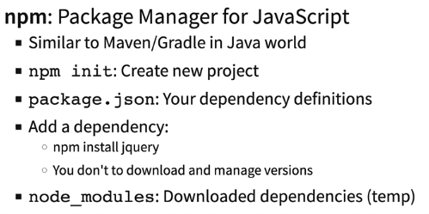

**Imp React Commands**

**npm start**: Runs the app in development mode Recommendation: Use Google Chrome.

**npm test**: Run unit tests (Junit ki tarah)

**npm run build**: Build a production deployable unit Minified Optimized for performance.

**npm install** **[dependency name]:** Add a dependency to the project.

**React Folder Structure**

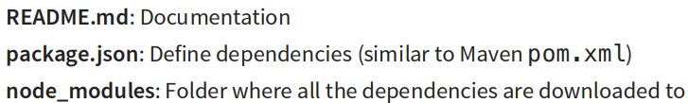.

**Note:**

**Index.html in public folder is the first file which is loaded in browser.**

**Every Javascript file is a called Module. In each Module, we create component (Function ya Class Component) and we pass this component to index.js which passes it to index.html.**

**App component is the first component which is passed to index.js which passes it to index.html by default.**

**index.css pure application ka styling file ka kaam krta hai but** **if we want for specific Component aage next pg pe dekh className tag se refer kr rahehai to the CSS file of that Component.**

**consider Component name is App.js then we can write unit test in App.test.js.**

**Ye sb src folder me krte hai.**

**Why Buid Application using Component? Components are modular (diff files jinhe ek jagah laake ek logic product bana sake).**

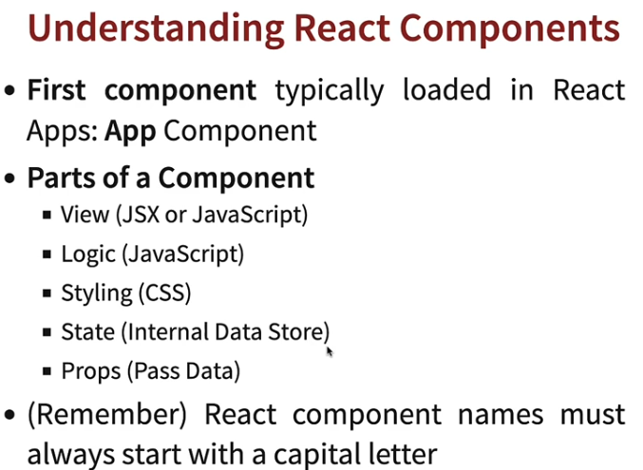

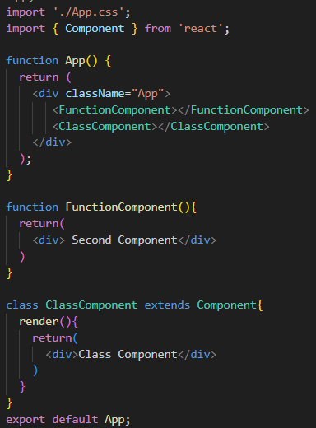**Function Component and Class Component**

**Function component** => returns a jsx file which will be displayed to the end user.

**Class Component** => render function creater inside a class and inside that function return jsx file.

Must import Component from ‘react’ and extend class with Component.

**Note**: **className** tag me we mention the name of the CSS file.

**Use Function Component only:**

**Reason:** Before node version 17, **state** (aage padhenge iske baare) sirf Class Compo ke paas tha, Function ke paas nhi.

But now due to introduction of Hooks **state** ka access function ke paas bhi hai.

**Note: Yaha ek hi module me diff components create kiya hai, usually ek component ek hi module me create krte hai.**

**React uses JSX (Javascript XML) stricter than HTML for view presentation.**

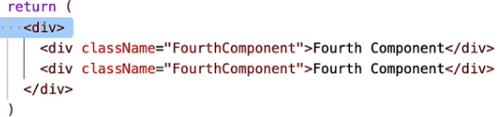Isme sirf top level tag allowed i.e. ek tag ke andar saare tagshone chahiye. RHS dekh.

Wrapping into a shared parent is must.

inside a **<div>…. </div>** tag ya phir **<>….. </>** empty wrapper.

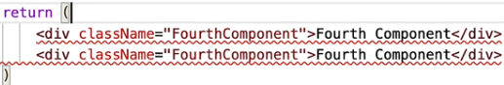Agar top level nhi to error

Browser cannot interpret JSX file so they internally uses Babel which converts JSX to JS and browser interprets that JS.

It is best Practice to have one component in a single module. Still we can have multiple components in a class.

**About Imports**

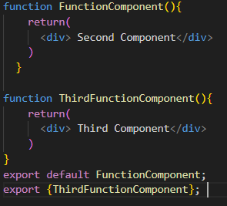Make sure to have only 1 default export baaki saare normal export.

Key Diff => Now it we import from this module, by default only FunctionComponent will be imported.

Since default export is FunctionComponent.

Note: We have named the import as FunctionComponent. We can name it anything.

This is known as **Default Import**

To import non default Component, mention that Component name inside **{}**

Make sure Component and Import name same ho. This is Known as **Named Export**

Importing from same vs sub directory.

